Semester One Examination 2018

Question/Answer Booklet

MATHEMATICS SPECIALIST
UNIT 1

Section One:
Calculator-free

Student Name: _____________________________________
Teacher‘s Name: _____________________________________

Time allowed for this section
Reading time before commencing work: five minutes
Working time for paper: fifty minutes

Material required/recommended for this section

To be provided by the supervisor
This Question/Answer booklet
Formula Sheet

To be provided by the candidate
Standard items: pens(blue/black preferred), pencils(including coloured), sharpener, correction tape/fluid, erasers, ruler, highlighters

Special Items: nil

Important note to candidates
No other items may be taken into the examination room. It is your responsibility to ensure that you do not have any unauthorised notes or other items of a non-personal nature in the examination room. If you have any unauthorised material with you, hand it to the supervisor before reading any further.

Structure of this paper

 | Number of questions available | Number of questions to be attempted | Suggested working time (minutes) | Marks available
Section One  Calculator—free | 7 | 7 | 50 minutes | 50
Section Two  Calculator—assumed | 12 | 12 | 100 minutes | 100
 |  |  |  | 150

Instructions to candidates

- The rules for the conduct of Western Australian external examinations are detailed in the Year 12 Information Handbook 2018. Sitting this examination implies that you agree to abide by these rules.

- Answer the questions according to the following instructions.

Section One: Write answers in this Question/Answer Booklet. Answer all questions.

Show all your working clearly. Your working should be in sufficient detail to allow your
answers to be checked readily and for marks to be awarded for reasoning. Incorrect
answers given without supporting reasoning cannot be allocated any marks. For any
question or part question worth more than two marks, valid working or justification is
required to receive full marks. If you repeat an answer to any question, ensure that you
cancel the answer you do not wish to have marked.

It is recommended that you do not use pencil, except in diagrams.

- You must be careful to confine your responses to the specific questions asked and to follow any instructions that are specific to a particular question.

- Spare pages are included at the end of this booklet. They can be used for planning your responses and/or as additional space if required to continue an answer.
- Planning: If you use the spare pages for planning, indicate this clearly at the top of the
page.
- Continuing an answer: If you need to use the space to continue an answer, indicate in the original answer space where the answer is continued, i.e. give the page number. Fill in the number of the question that you are continuing to answer at the top of the page.

- The Formula Sheet is not handed in with your Question/Answer Booklet.

Section One: Calculator–free 50 marks

This section has seven (7) questions. Attempt all questions. Write your answers in the spaces provided.

Working time: 50 minutes

Question 1 (6 marks)

Points A and B have position vectors $a=2i+j$ and $b=i+3j$ respectively.

(a) Show that $a$ is perpendicular to $b-a$. (3 marks)

(b) Given that OABC is a square, with O as the origin, state:

(i) the position vector of vertex C. (1 mark)

(ii) $\left|\vec{AC}\right|$ (2 marks)

Question 2 (8 marks)

(a) Evaluate each of the following.

(i) $\frac{13!+12!}{13!-12!}$ (2 marks)

(ii) $\frac{{}_{ }^{10}{C_{4}}}{{}_{ }^{8}{C_{4}}}$ (2 marks)

(b) Show that $k\left(\begin{matrix}n \\ k\end{matrix}\right)=n\left(\begin{matrix}n-1 \\ k-1\end{matrix}\right)$ is true for all integers $n,k$ with $n>k$. (4 marks)

Question 3 (7 marks)

Consider the following statements.

A: If $m>n$, with $m,n∈R$, then $m^{2}>n^{2}$.
B: If the triangle has three equal angles, then the triangle is equilateral.
C: $∀ p∈N,∃ q∈R$ such that $q=\sqrt{p}$
D: If $n$ is divisible by 6, then $n$ is divisible by 3.

(a) Provide a counter example for statement A. (1 mark)

(b) Write down the contrapositive of statement B.
Is the contrapositive always true? Explain. (2 marks)

(c) Write down the converse of statement D.
Is the converse always true? Explain. (2 marks)

(d) Rewrite statement C in words. (2 marks)

Question 4 (10 marks)

Consider the vectors $a$ and $b$ shown below.

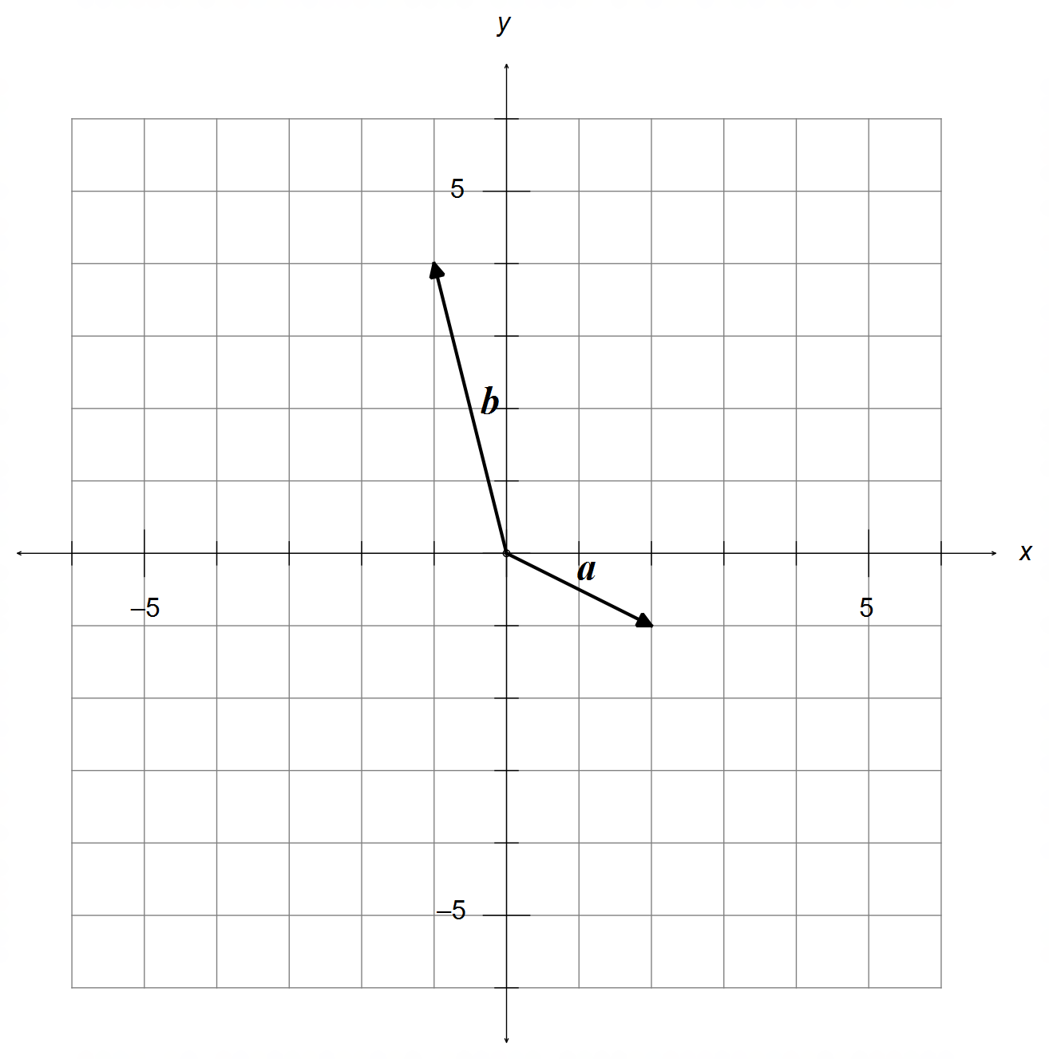

(a) Find a vector $u$ that is parallel to $a+b$ with a magnitude of $2\sqrt{10}$ units.
Sketch $u$ on the same grid above. (4 marks)

Question 4 – Continued

Vector $c=\left(\begin{matrix}-4 \\ α\end{matrix}\right)$ where $α∈R$.

(b) Find $α$ given that:

(i) $a$ and $c$ are parallel. (2 marks)

(ii) $\left|c-b\right|=3\left|a\right|$ (4 marks)

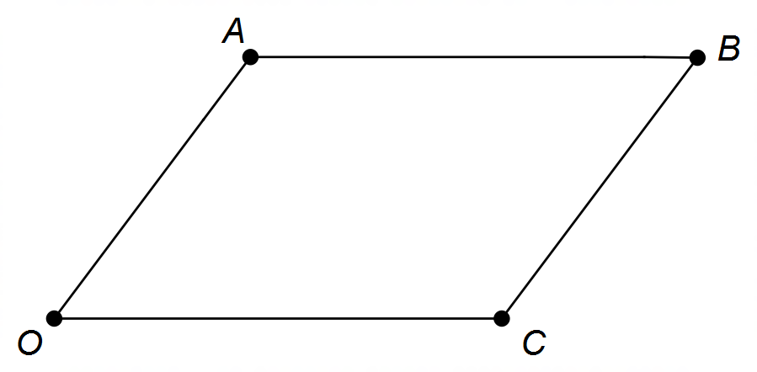Question 5 (7 marks)

The diagram shows parallelogram OABC.
Let: $\vec{OA}=a$ and $\vec{OC}=c$.

(a) Use the fact that AC and OB are perpendicular to prove that OABC is a rhombus. (3 marks)

(b) Show that the sum of the squares of the lengths of the diagonals of a parallelogram is
equal to the sum of the squares of the lengths of the sides. (4 marks)

Question 6 (8 marks)

Consider the circle shown below with centre at O and diameter AD, with TS tangent to the circle at C.
Points B and E lie on the circumference with EA parallel to BC, ∠ADE = 60° and ∠ABC = 40°.

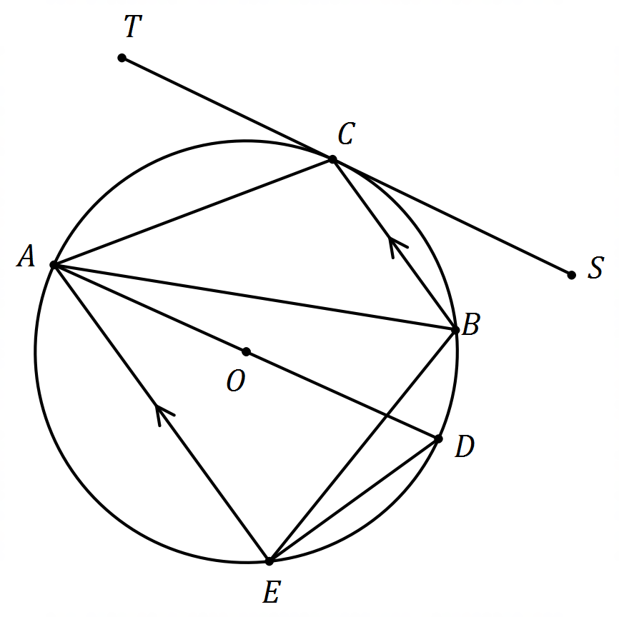

Determine the size of the following angles giving reason(s) to justify your answer.

(a) ∠AED (2 marks)

(b) ∠ABE (2 marks)

(c) ∠CAE (2 marks)

(d) ∠TCE (2 marks)

Question 7 (4 marks)

Points A, B and C have position vectors $a=xi-j$, $b=i+3j$ and $c=4i+yj$ respectively,
where $x,y∈R$.

Given that AB:BC = 2:1, determine the value(s) of $x$ and $y$. (4 marks)

End of Section One
Additional working space

Question number(s): ……………………

Additional working space

Question number(s): ……………………

